Urban Traffic Congestion Time Analysis
Abstract
Urban traffic congestion refers to the increase in vehicle movement on roads during certain periods, which leads to slower travel, delays, and reduced road efficiency. It is one of the most common challenges in growing cities because traffic conditions are influenced by time of day, road usage, weather situations, and unexpected incidents on roads. Understanding congestion patterns is important because it helps explain when traffic becomes severe, which routes experience higher pressure, and what conditions increase travel delay. This project examines urban traffic records by studying factors such as city zones, road types, traffic volume, average vehicle speed, weather conditions, accident reports, travel time, and congestion levels. This analysis helps identify peak congestion hours, periods of heavy vehicle movement, and road situations where delays occur more frequently. It also explains how weather conditions such as rain or storms affect travel time and how accident-related incidents contribute to congestion severity. By comparing these patterns across different traffic conditions, the project provides a clearer understanding of urban road behaviour and highlights the main factors that influence traffic delays and road performance.
2. INTRODUCTION
Urban transportation systems are a fundamental part of modern cities, enabling the movement of people and goods across different regions. With rapid urbanization and population growth, the number of vehicles on roads has increased significantly, leading to frequent traffic congestion. Traffic congestion is not only a matter of inconvenience but also a complex urban challenge that affects economic productivity, environmental conditions, and overall quality of life. It occurs when the demand for road space exceeds its capacity, resulting in slower speeds, increased travel time, and higher fuel consumption. Various factors such as peak working hours, road infrastructure, traffic signals, weather conditions, and unexpected incidents like accidents contribute to congestion levels in cities.
In this context, analyzing traffic data becomes highly important. Large volumes of traffic-related data are continuously generated from different sources such as road sensors, GPS systems, and traffic monitoring systems. This data contains valuable information about vehicle movement, speed patterns, traffic density, and travel delays. Without proper analysis, this data remains unused and does not contribute to solving traffic-related issues. By systematically analyzing this data, it is possible to identify patterns such as peak congestion hours, frequently affected areas, and conditions that lead to delays. Such analysis helps in understanding how traffic behaves under different circumstances and enables better decision-making.
The importance of data analysis lies in its ability to transform raw data into meaningful insights. In the case of urban traffic, data analysis helps in identifying trends and relationships between variables such as traffic volume, average speed, weather conditions, and accident occurrences. For example, analyzing how rainfall affects vehicle speed or how accidents influence travel time can provide useful information for traffic management authorities. Similarly, identifying high congestion zones can help in planning alternative routes or improving road infrastructure. Data analysis also supports efficient resource allocation, such as optimizing traffic signal timings and managing traffic flow during peak hours.
Analytics plays a crucial role in solving real-world problems by providing a systematic approach to understanding complex systems. In this project, analytics is used to study urban traffic congestion through data preprocessing, feature engineering, and both Python-based and SQL-based analysis. By applying analytical techniques, hidden patterns and relationships within the dataset are uncovered. This helps in gaining a deeper understanding of how different factors interact and contribute to congestion.
Furthermore, analytics enables predictive and descriptive insights that can support better planning and decision-making. Although this project focuses on descriptive analysis, the insights generated can serve as a foundation for future improvements in traffic systems. For instance, identifying peak congestion periods can help in implementing traffic control measures, while understanding the impact of weather and accidents can improve emergency response planning.
Overall, the role of analytics in this project is to convert complex traffic data into actionable insights. By doing so, it contributes to addressing the real-world problem of urban traffic congestion and highlights how data-driven approaches can improve efficiency, reduce delays, and enhance transportation systems in growing cities.
3. EXISTING SYSTEM
In the existing system, urban traffic data is primarily stored in Excel files where records are maintained in a tabular format. Each row represents a traffic record containing details such as date and time, city zone, road type, traffic volume, average speed, weather conditions, accident status, travel time, and congestion level. The data is typically entered manually or collected from basic sources and then updated into spreadsheets for storage.
The process of data entry in this system is largely manual, which increases the chances of human errors such as incorrect values, missing entries, or inconsistent formatting. Since Excel files are not designed for handling large-scale data efficiently, managing and updating large datasets becomes time-consuming and difficult. Additionally, maintaining multiple Excel files can lead to duplication of data and lack of proper data organization.
The existing system is mainly used for viewing and storing records rather than performing advanced analysis. While Excel provides basic filtering and sorting capabilities, it does not support efficient querying, complex data transformations, or large-scale analytical operations. As a result, identifying patterns, trends, or relationships within the traffic data becomes challenging.
Due to these limitations, the existing system is not sufficient for generating meaningful insights or supporting data-driven decision-making. This creates the need for a more structured and analytical approach using tools like Python and SQL, which can handle large datasets and provide deeper insights into traffic congestion patterns.
4. DISADVANTAGES OF EXISTING SYSTEM
The existing system of storing and managing traffic data using Excel files has several limitations that affect the efficiency, accuracy, and usefulness of the data. These disadvantages make it difficult to perform meaningful analysis and highlight the need for a more advanced data analytics approach.
- Human errors in data entry
Since the data is entered manually into Excel sheets, there is a high possibility of human errors. These errors may include incorrect values, missing entries, duplication of records, or inconsistent formatting. Even small mistakes can affect the overall accuracy of the dataset and lead to incorrect conclusions during analysis.
- Time-consuming process
Managing and updating data manually in Excel requires a significant amount of time and effort. Tasks such as sorting, filtering, and updating records become repetitive and slow, especially when dealing with large datasets. This reduces productivity and delays the analysis process.
- Lack of proper analytical capabilities
The existing system is mainly used for storing and viewing data rather than analyzing it. Excel provides only basic functions for filtering and simple calculations, which are not sufficient for performing complex data analysis. It becomes difficult to identify patterns, trends, and relationships between different variables such as traffic volume, speed, and congestion levels.
- Difficulty in handling large datasets
As the volume of traffic data increases, managing it in Excel becomes challenging. Large datasets can slow down performance, make navigation difficult, and increase the chances of data corruption. Handling multiple files also leads to poor organization and confusion.
- Limited data integration and scalability
Excel-based systems do not support seamless integration with other tools or databases. This makes it difficult to combine data from different sources or scale the system for future requirements. As data grows, the system becomes inefficient and harder to maintain.
- Lack of real-time analysis and automation
The existing system does not support automation or real-time data processing. Any updates or analysis must be done manually, which limits the ability to quickly respond to changing traffic conditions or generate timely insights.
These disadvantages highlight the limitations of the current system and emphasize the need for a more structured, efficient, and analytical approach using modern data analytics tools.
5. PROPOSED SYSTEM
The proposed system is designed to overcome the limitations of the existing Excel-based approach by introducing a structured and efficient data analytics workflow. It integrates data storage, querying, and processing using MySQL and Python to generate meaningful insights from urban traffic data. This system ensures better data organization, faster analysis, and improved accuracy.
The overall system follows a step-by-step flow where raw data is first collected in the form of Excel or CSV files. This data is then imported into a MySQL database, where it is stored in a structured format. SQL queries are applied to extract, filter, and aggregate the data based on different conditions. After this, Python with the Pandas library is used for further processing, feature engineering, and advanced analysis. Finally, the results are generated in the form of summarized outputs and insights.
System Flow
Excel or CSV Dataset is used as the initial source of raw traffic data.
The dataset is then loaded into a MySQL database for structured storage.
SQL queries are executed to perform filtering, grouping, and aggregation.
The processed data is then handled in Python for deeper analysis and transformations.
Final results are generated as meaningful insights and interpreted outputs.
In this system, SQL plays a key role in managing and querying the data efficiently. Once the dataset is stored in MySQL, SQL is used to perform operations such as grouping traffic data by hour, analyzing congestion levels across city zones, and calculating average values like traffic volume and speed. SQL allows quick retrieval of specific information from large datasets using conditions, joins, and aggregation functions. It helps in summarizing the data and preparing it for further analysis.
Python is used after SQL to perform advanced data processing and analytical operations that are not easily achievable through SQL alone. Using the Pandas library, the data is cleaned, transformed, and enriched through feature engineering. New columns such as hour, peak period, speed category, traffic density, and delay factor are created to provide deeper insights. Python also enables flexible analysis such as identifying patterns, comparing multiple conditions, and performing customized calculations.
The combination of SQL and Python makes the proposed system highly efficient and scalable. SQL ensures fast and structured data retrieval, while Python enhances analytical capabilities through dynamic processing. This integrated approach allows the system to generate accurate insights about traffic congestion patterns, making it more effective than the existing manual system.
6. ADVANTAGES OF PROPOSED SYSTEM
The proposed system offers significant improvements over the traditional Excel-based approach by integrating MySQL and Python for efficient data handling and analysis. It enhances the overall performance, accuracy, and usability of the traffic data analysis process. The following are the key advantages of the proposed system.
- Faster analysis
The proposed system significantly reduces the time required for data analysis. By storing data in a MySQL database, large volumes of records can be processed quickly using optimized SQL queries. Instead of manually filtering and sorting data in Excel, queries can retrieve required results instantly. Additionally, Python automates data processing tasks such as cleaning, transformation, and feature engineering, which further speeds up the workflow. This allows analysts to focus more on interpretation rather than manual operations.
- Accurate results
Accuracy is greatly improved in the proposed system as it minimizes manual intervention. Automated data cleaning and type conversion in Python reduce the chances of errors caused by incorrect data formats or missing values. SQL queries ensure consistent calculations using well-defined functions such as aggregation and grouping. Since the entire process is systematic and repeatable, the results produced are more reliable and free from human inconsistencies.
- Organized data management
Storing data in a structured MySQL database ensures better organization compared to scattered Excel files. Data is maintained in tables with clearly defined columns and data types, making it easier to manage and access. This structured format reduces duplication, improves data integrity, and allows efficient handling of large datasets. It also makes updating, modifying, and retrieving data more convenient.
- Easy query-based insights
The use of SQL enables easy extraction of insights through simple and readable queries. Analysts can quickly perform operations such as filtering specific conditions, grouping data, and calculating averages or counts. This makes it easier to answer analytical questions such as identifying peak traffic hours or comparing congestion levels across different zones. Query-based analysis is flexible and can be modified easily to explore different perspectives of the data.
- Improved scalability
The proposed system is capable of handling increasing volumes of data without significant performance issues. Unlike Excel, which becomes slow with large datasets, MySQL efficiently manages and processes large-scale data. This makes the system suitable for real-world applications where data continuously grows over time.
- Better analytical capabilities
By combining SQL with Python, the system supports both structured querying and advanced analytical operations. Python enables the creation of new features, complex calculations, and deeper analysis that go beyond basic querying. This results in more meaningful insights and a better understanding of traffic patterns.
- Reduced redundancy and improved consistency
Centralized data storage in a database reduces duplication and ensures consistency across records. Since all data is maintained in a single system, it becomes easier to maintain uniformity and avoid conflicts between multiple files.
Overall, the proposed system provides a more efficient, accurate, and scalable solution for analyzing urban traffic data. It transforms raw data into meaningful insights in a structured and systematic manner, making it highly suitable for real-world data analytics applications.
7. INTRODUCTION TO APPLICATION
The application developed in this project is a data analytics system designed to analyze urban traffic congestion using structured data. Its primary purpose is to transform raw traffic records into meaningful insights that help in understanding traffic patterns, congestion levels, and factors affecting travel time. The system combines the capabilities of MySQL for data storage and querying with Python for data processing and analysis, providing a complete workflow for handling traffic data efficiently.
The system works by taking traffic data as input in the form of Excel or CSV files and storing it in a MySQL database. Once the data is stored, it can be accessed and analyzed using SQL queries. These queries help in extracting specific information such as peak traffic hours, congestion levels in different city zones, and the impact of weather or accidents on travel time. The application is designed to support analytical operations rather than simple data storage, making it more useful for deriving insights.
User interaction with the system is mainly through query execution and result interpretation. The user can write and execute SQL queries in MySQL to retrieve required data based on different conditions. For example, the user can query to find the average traffic volume at different hours or identify areas with high congestion. After retrieving the results from SQL, the user can further process the data using Python in Jupyter Notebook. In Python, additional transformations and feature engineering are performed, and deeper analysis is carried out to uncover patterns that are not directly visible through SQL queries.
The flow of data in the application follows a structured sequence. Initially, raw data is collected and loaded into the system. This data is then cleaned and transformed using Python to ensure consistency and accuracy. After preprocessing, the data is stored in the MySQL database, where it is organized into tables. SQL queries are then applied to extract and summarize the data. The output from these queries can be further analyzed in Python to generate advanced insights. Finally, the results are presented in the form of summarized tables and interpretations.
Overall, the application provides a systematic approach to analyzing urban traffic data. It allows users to interact with the data through queries and analytical tools, enabling them to explore patterns, understand congestion behavior, and generate meaningful conclusions from the dataset.
8. BLOCK DIAGRAM
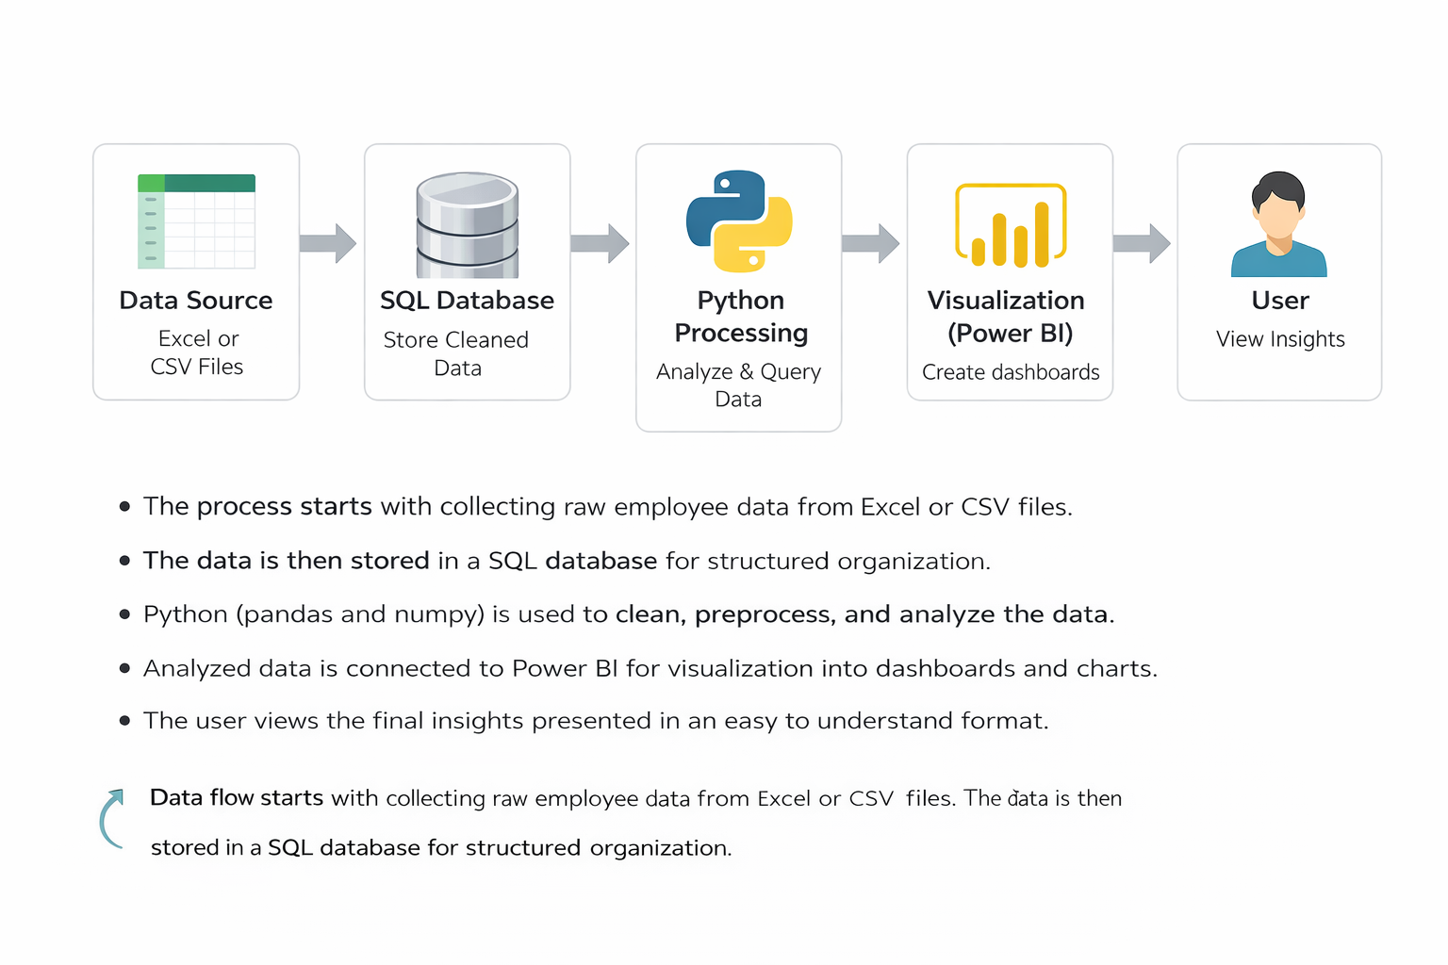
Data Source → SQL Database → Python Processing → User
The above block diagram represents the flow of data and processing in the proposed traffic congestion analysis system. Each block plays an important role in transforming raw data into meaningful insights.
Data Source
The data source is the starting point of the system. It consists of traffic data stored in Excel or CSV files. This data includes information such as date and time, city zone, road type, traffic volume, average speed, weather conditions, accident reports, travel time, and congestion levels. The data collected at this stage is raw and may contain inconsistencies, which require further processing.
SQL Database
The SQL database, specifically MySQL in this project, is used to store the data in a structured format. Once the data is imported from Excel or CSV files, it is organized into tables with defined columns and data types. The database allows efficient storage, retrieval, and management of large volumes of data. SQL queries are used at this stage to filter, group, and aggregate the data, enabling quick extraction of useful information.
Python Processing
Python is used for data cleaning, transformation, and advanced analysis. Using libraries such as Pandas, the data is processed to handle missing values, correct data types, and create new features like hour, peak period, traffic density, and delay factor. Python also enables deeper analysis by applying custom logic and calculations that are not easily performed using SQL alone. This step enhances the quality of insights generated from the data.
User
The user is the final component of the system who interacts with the results. The user executes SQL queries to retrieve specific information and uses Python outputs to understand patterns and trends in the data. The results are presented in the form of tables and analytical interpretations, which help the user draw meaningful conclusions about traffic congestion.
This block diagram represents a simple and efficient workflow where data flows from raw input to structured storage, then to analytical processing, and finally to the user for interpretation.
9. DATA ANALYTICS SECTION
9.1 Overview
The data analytics section focuses on extracting meaningful insights from the urban traffic dataset using structured and systematic techniques. The primary objective of this section is to analyze traffic patterns, understand congestion behavior, and identify the key factors that influence travel time and road efficiency. By applying data analytics methods, raw traffic data is transformed into useful information that supports better understanding and decision-making.
The analysis is carried out using two main technologies, MySQL and Python with the Pandas library. MySQL is used for storing the dataset and performing structured queries such as filtering, grouping, and aggregation. These queries help in summarizing large volumes of data and identifying general patterns such as peak traffic hours, congestion levels across different zones, and variations in traffic volume. Python is used for data preprocessing, feature engineering, and advanced analysis. It allows more flexibility in handling data and performing customized computations that are not easily achievable using SQL alone.
The dataset used in this project contains multiple attributes related to traffic conditions, including date and time, city zone, road type, traffic volume, average speed, weather conditions, accident reports, travel time, and congestion levels. These variables provide a comprehensive view of urban traffic behavior and enable multi-dimensional analysis. By examining relationships between these attributes, the analysis aims to uncover patterns such as how traffic volume affects congestion, how weather conditions influence speed, and how accidents impact travel time.
A key part of the analytics process involves feature engineering, where new variables such as hour, day of the week, peak period, speed category, traffic density, and delay factor are created. These additional features enhance the dataset and allow deeper insights into traffic patterns. For example, analyzing data based on peak and non-peak periods helps in understanding congestion during busy hours, while traffic density provides a measure of how crowded the roads are.
Overall, this section provides a structured approach to analyzing traffic data by combining SQL-based querying and Python-based processing. The insights generated from this analysis help in understanding the dynamics of urban traffic congestion and highlight the importance of data analytics in solving real-world problems related to transportation systems.
9.2 Data Description
The dataset used in this project contains multiple attributes related to urban traffic conditions. Each column represents a specific aspect of traffic behavior, which helps in analyzing congestion patterns and identifying factors affecting travel time. The data includes a mix of datetime, categorical, and numerical variables, each serving a unique purpose in the analysis.
Columns
The dataset consists of the following columns:
The date_time column stores the timestamp of each traffic record. It is used to analyze traffic patterns based on time and to extract features such as hour and day of the week.
The city_zone column represents different areas within the city. It helps in identifying which zones experience higher congestion levels.
The road_type column indicates the type of road, such as highways or local roads. This helps in comparing traffic conditions across different road categories.
The traffic_volume column shows the number of vehicles on the road. It is an important factor in measuring traffic intensity and congestion.
The average_speed_kmph column represents the average speed of vehicles in kilometers per hour. It helps in understanding how traffic flow changes under different conditions.
The weather_condition column provides information about weather situations such as clear, rainy, or stormy conditions. This helps in analyzing how weather affects traffic movement.
The accident_reported column indicates whether an accident occurred or not. It is useful for studying the impact of incidents on traffic delays.
The travel_time_minutes column shows the time taken to travel a certain distance. It is a key metric for measuring congestion and delays.
The congestion_level column categorizes traffic conditions into levels such as low, medium, or high. It helps in understanding the severity of traffic congestion.
In addition to the original columns, new columns are created through feature engineering to enhance the analysis . These include hour, day_of_week, peak_period, speed_category, traffic_density, and delay_factor, which provide deeper insights into traffic patterns and behavior.
Data Types
The dataset contains different types of data to support comprehensive analysis. The date_time column is stored as a datetime type, allowing time-based operations. Columns such as city_zone, road_type, weather_condition, accident_reported, and congestion_level are categorical in nature, as they represent distinct groups or categories. The traffic_volume, average_speed_kmph, and travel_time_minutes columns are numerical, enabling calculations such as averages, ratios, and comparisons. The newly created columns also include both categorical and numerical types depending on their purpose.
Purpose of the Data
The primary purpose of this dataset is to analyze urban traffic congestion and understand the factors that influence it. Each column contributes to a specific aspect of the analysis. Time-related columns help in identifying peak traffic hours, location-based columns help in comparing different city zones, and condition-based columns such as weather and accidents provide context for variations in traffic flow.
The dataset enables the study of relationships between variables, such as how traffic volume affects speed, how weather conditions influence travel time, and how accidents contribute to congestion. By combining these attributes, the data supports a comprehensive analysis of traffic behavior and helps in generating meaningful insights that can be used for improving traffic management and planning.
9.3 Data Preprocessing
Data preprocessing is a crucial step in the data analytics process, as it ensures that the dataset is clean, consistent, and suitable for analysis. Raw data often contains errors, inconsistencies, and missing values that can affect the accuracy of results. Therefore, preprocessing is performed to improve data quality and prepare it for further analysis using SQL and Python.
Cleaning
The cleaning process involves correcting inconsistencies and standardizing the dataset. All column names are converted to lowercase and spaces are replaced with underscores to maintain uniform naming conventions. This helps in avoiding errors during coding and querying. Incorrect data types are identified and converted into appropriate formats. For example, the date_time column is converted into a datetime format to enable time-based analysis. Duplicate records, if any, are removed to ensure that the dataset contains only unique and valid entries. These steps help in improving the reliability and consistency of the data.
Handling Missing Values
Missing values are a common issue in real-world datasets and need to be handled carefully. In this project, missing or invalid values are identified and addressed during preprocessing. Depending on the nature of the data, missing values are either removed or replaced using appropriate techniques. For numerical columns such as traffic volume, average speed, and travel time, missing values can be replaced with mean or median values if necessary. For categorical columns such as weather condition or congestion level, missing entries can be filled with the most frequent category or labeled as unknown. Proper handling of missing values ensures that the analysis is not biased or inaccurate.
Formatting
Formatting ensures that the data is stored in a consistent and usable structure. Date and time values are formatted correctly to allow extraction of features such as hour and day of the week. Numerical columns are formatted to ensure they contain valid numeric values for calculations. Categorical data is standardized to avoid variations in naming, such as differences in capitalization or spelling. This step ensures uniformity across the dataset, making it easier to perform grouping, filtering, and analysis.
Overall, data preprocessing improves the quality and usability of the dataset. By cleaning the data, handling missing values, and ensuring proper formatting, the dataset becomes reliable for analysis, leading to more accurate and meaningful insights.
9.4 Exploratory Data Analysis
Exploratory Data Analysis is an important step in understanding the dataset before performing detailed analysis. It focuses on examining the data to identify trends, patterns, and key observations. This process helps in gaining an initial understanding of how different variables behave and how they are related to each other. In this project, exploratory analysis is performed using both SQL queries and Python to study traffic behavior under different conditions.
Trends
The analysis of trends helps in understanding how traffic conditions change over time and across different scenarios. One of the major trends observed in the dataset is the variation of traffic volume and travel time across different hours of the day. Traffic volume tends to increase during specific time intervals, especially during morning and evening periods, indicating peak hours. Similarly, travel time shows a rising trend during these periods due to increased congestion.
Another important trend is observed in relation to weather conditions. During unfavorable weather such as rain or storms, the average speed of vehicles tends to decrease, leading to an increase in travel time. This shows that environmental factors play a significant role in influencing traffic flow. Trends related to accidents also indicate that the presence of incidents on the road contributes to longer travel times and increased congestion levels.
Patterns
Patterns in the data reveal consistent relationships between different variables. A clear pattern can be seen between traffic volume and average speed, where higher traffic volume generally leads to lower vehicle speed. This inverse relationship highlights how increased road usage affects movement efficiency. Similarly, a pattern exists between congestion level and travel time, where higher congestion levels are associated with longer travel durations.
Another important pattern is observed across different city zones and road types. Certain zones consistently experience higher traffic volume and congestion, indicating that these areas are more prone to traffic issues. Road types such as major roads or highways may show different traffic behavior compared to smaller roads, reflecting variations in capacity and usage.
Patterns are also visible in the relationship between speed categories and congestion levels. Records categorized under slow speeds are often associated with high congestion, while faster speeds correspond to lower congestion levels. These consistent patterns help in understanding how different factors interact within the traffic system.
Observations
Several key observations can be derived from the exploratory analysis. Peak traffic hours are identified as the most congested periods, where both traffic volume and travel time are at their highest. Weather conditions significantly impact traffic flow, with adverse weather leading to slower speeds and increased delays. Accidents are found to contribute to sudden increases in travel time, indicating their strong effect on congestion.
It is also observed that traffic conditions vary across different locations, with certain city zones experiencing consistently higher congestion levels. Additionally, higher traffic density often results in reduced speed and increased delay, highlighting the importance of managing road usage effectively.
Overall, exploratory data analysis provides a clear understanding of the dataset by identifying important trends, patterns, and observations. These insights form the foundation for further analysis and help in explaining the factors that influence urban traffic congestion.
9.5 TOOLS USED
The following tools are used in this project to perform data processing, analysis, storage, and visualization. Each tool plays a specific role in the overall workflow.
1. Python
Python is the core programming tool used for implementing the entire data analysis process. It is used to write scripts for data cleaning, transformation, and analysis.

2. Jupyter Notebook
Jupyter Notebook is used as the development tool where Python code is written and executed. It provides an interactive environment to run code step-by-step and view outputs instantly.

3. Pandas
Pandas is used for data manipulation and handling structured data. It helps in reading datasets, filtering data, grouping values, and creating new columns required for analysis.
4. MySQL
MySQL is used as the database tool for storing and managing the dataset. It allows execution of SQL queries to retrieve and analyze data efficiently.

10. SOFTWARE REQUIREMENTS
Software requirements refer to the platforms and environments needed to develop, run, and execute the project. These provide the base setup where all tools and libraries function.
1. Operating System
The project can run on operating systems such as Windows, macOS, or Linux. In this project, a Windows environment is typically used, which supports Python, Jupyter Notebook, and other required tools. The operating system manages file handling, software installation, and execution of programs.

2. Python Environment
Python is required as the core programming language. A proper Python environment must be installed to execute scripts and run data analysis.
In this project:
- Python is used to write all preprocessing and analysis logic
- It acts as the base for libraries like pandas, NumPy, and matplotlib
- Version compatibility is important to ensure smooth execution

3. Jupyter Notebook Environment
Jupyter Notebook is required as the development platform for writing and running code interactively.
In this project:
- It provides an interface to execute Python code step-by-step
- It allows combining code, outputs, and explanations in one place
- It helps in testing and debugging during development

4. Library Support (Python Packages)
The system requires installation of essential Python libraries. These are not standalone software but part of the Python environment.
Required libraries include:
- pandas for data handling
- NumPy for numerical operations
- matplotlib for visualization
These libraries must be installed using package managers such as pip before running the project.

5. Database Software (MySQL)
MySQL is used as the database system for storing and querying structured data.
In this project:
- It stores insurance dataset in table format
- SQL queries are executed to filter and analyze data
- It supports structured data management and retrieval

7. Web Browser
A web browser such as Chrome or Edge is required to access Jupyter Notebook and Power BI interfaces. It provides the interface for interacting with dashboards and notebooks.

11. HARDWARE REQUIREMENTS
1. Processor
- Minimum Intel Core i3 or equivalent
- Recommended Intel Core i5 or higher
The processor is responsible for executing all operations in the system. A basic processor like i3 can handle small datasets and simple analysis. However, for better performance, especially when running multiple tools such as Jupyter Notebook and Power BI together, a higher processor like i5 or above is preferred. A faster processor reduces computation time and improves overall system responsiveness.
2. RAM
- Minimum 4 GB RAM
- Recommended 8 GB or more
RAM is used to temporarily store data during execution. A minimum of 4 GB is sufficient for basic tasks, but it may cause slow performance when handling larger datasets. Using 8 GB or more allows smoother multitasking and faster data processing. Higher RAM ensures that the system does not lag when multiple applications are running.
3. Storage
- Minimum 256 GB storage
- Recommended SSD storage
Storage is required to install software and store datasets and project files. A minimum of 256 GB is needed for proper functioning. Solid State Drives are recommended over traditional hard drives because they provide faster data access and improve system speed. Faster storage reduces loading time and enhances performance.
4. Operating System
- Windows, macOS, or Linux supported
- Recommended 64-bit Windows 10 or above
The operating system acts as the base platform for running all tools and applications. A 64-bit system is recommended for better compatibility and performance. Windows 10 or higher is commonly used as it supports all required software such as Python, MySQL, and Power BI efficiently.
Summary
The hardware components play an important role in ensuring smooth execution of the project. A good processor, sufficient RAM, fast storage, and a compatible operating system together provide a stable and efficient working environment.

Why These Hardware Requirements Are Sufficient for the Project
The specified hardware configuration is sufficient for this project because the nature of the work involves moderate data processing, analysis, and visualization, rather than extremely heavy computations or large-scale distributed systems. Each component supports the project requirements effectively.
Processor Sufficiency
The project mainly uses Python, Jupyter Notebook, SQL queries, and Power BI dashboards. These tasks involve data manipulation, filtering, grouping, and visualization, which do not require very high-end processing power. A processor like Intel Core i3 can handle these operations without major issues. However, using an i5 or higher ensures faster execution when performing multiple operations or running several tools at the same time. Since the dataset is of manageable size and not extremely large, this level of processing power is sufficient.
RAM Sufficiency
The dataset used in this project is structured and moderate in size, meaning it can easily fit into memory. A minimum of 4 GB RAM is enough to load and process such data in pandas and NumPy. However, when using tools like Power BI along with Jupyter Notebook, additional memory is beneficial. With 8 GB RAM, the system can handle multitasking smoothly, ensuring that data analysis, visualization, and querying operations run without lag. Therefore, this RAM range is adequate for efficient performance.
Storage Sufficiency
The project requires storage for datasets, software installations, and output files such as reports and dashboards. The data size is not extremely large, so 256 GB storage is more than enough to accommodate all files. Using SSD storage further improves performance by reducing loading times and speeding up file access. This ensures quick opening of datasets, faster execution of notebooks, and smooth operation of Power BI dashboards.
Operating System Sufficiency
The project tools such as Python, Jupyter Notebook, MySQL, and Power BI are fully compatible with modern operating systems like Windows, macOS, and Linux. A 64-bit operating system ensures better memory utilization and supports all required software efficiently. Windows 10 or above is commonly used and provides a stable environment for running all components without compatibility issues. Therefore, the operating system requirement is sufficient for seamless execution.
Overall Justification
The project does not involve heavy machine learning models, real-time big data processing, or high-performance computing tasks. Instead, it focuses on structured data analysis, visualization, and dashboard creation. The specified hardware is capable of handling these operations efficiently without unnecessary resource usage. It provides a balanced configuration that ensures smooth performance, cost-effectiveness, and practical usability for real-world implementation.
12. METHODOLOGY
The methodology followed in this project outlines a structured approach to analyzing urban traffic congestion data. Each step is carefully designed to ensure that the data is properly prepared, analyzed, and interpreted to generate meaningful insights.
Data Collection
The first step involves collecting the traffic dataset in the form of Excel or CSV files. The dataset contains detailed information about traffic conditions, including date and time, city zones, road types, traffic volume, average speed, weather conditions, accident reports, travel time, and congestion levels. This raw data serves as the foundation for the entire analysis process.
Data Cleaning using Python
Once the data is collected, it is processed using Python in Jupyter Notebook. The Pandas library is used to clean and prepare the dataset. Column names are standardized by converting them to lowercase and replacing spaces with underscores. Data types are corrected by converting date_time into datetime format, categorical columns into category types, and numerical columns into appropriate numeric formats. Missing values and inconsistencies are handled to ensure data accuracy. Feature engineering is also performed at this stage by creating new columns such as hour, day of the week, peak period, speed category, traffic density, and delay factor, which enhance the analytical capability of the dataset.
Data Storage using SQL
After cleaning and transformation, the dataset is stored in a MySQL database. The data is organized into structured tables with clearly defined columns and data types. Storing data in a database improves data management, ensures consistency, and allows efficient handling of large datasets. This step enables easy access and retrieval of data for further analysis.
Query-Based Analysis
SQL is used to perform query-based analysis on the stored data. Various queries are written to extract meaningful information, such as identifying peak traffic hours, analyzing congestion levels across different city zones, and studying the impact of weather conditions and accidents on travel time. Aggregation functions such as average and count are used along with grouping and filtering techniques to summarize the data and identify patterns.
Result Interpretation
The final step involves interpreting the results obtained from SQL queries and Python analysis. The outputs are analyzed to identify trends, patterns, and relationships between different variables. These interpretations help in understanding the factors contributing to traffic congestion and provide insights into traffic behavior. The results are presented in a clear and structured manner, making it easier to draw meaningful conclusions from the analysis.
This step-by-step methodology ensures a systematic and efficient approach to data analysis, transforming raw traffic data into valuable insights that can support better understanding and decision-making.
13. UML DIAGRAMS
Use Case Diagram
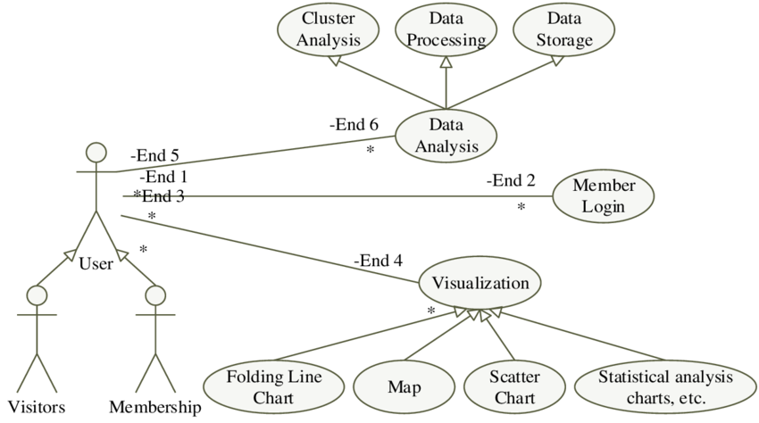
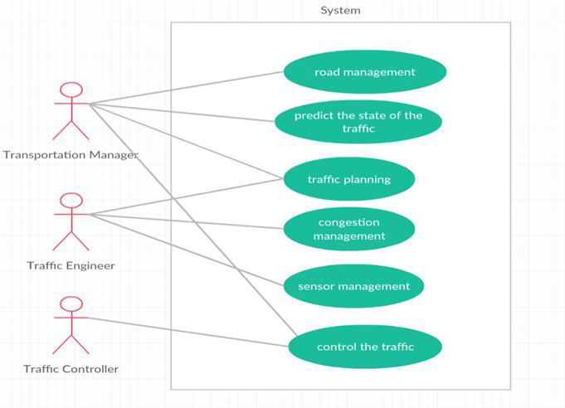

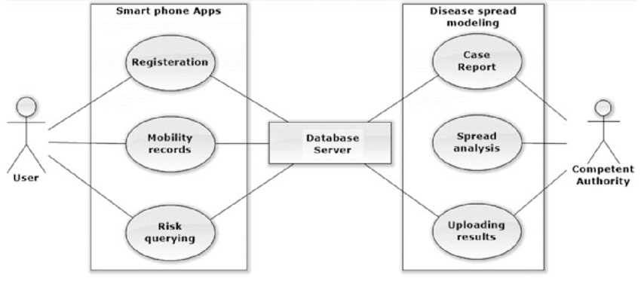
The use case diagram represents how the user interacts with the system. In this project, the main user is the analyst who performs data analysis.
The user uploads the dataset, stores it in the SQL database, runs queries to extract information, processes the data using Python, and views the results. Each of these actions represents a use case. The system supports these operations and provides outputs based on user input. This diagram helps in understanding the overall functionality from a user perspective.
Class Diagram
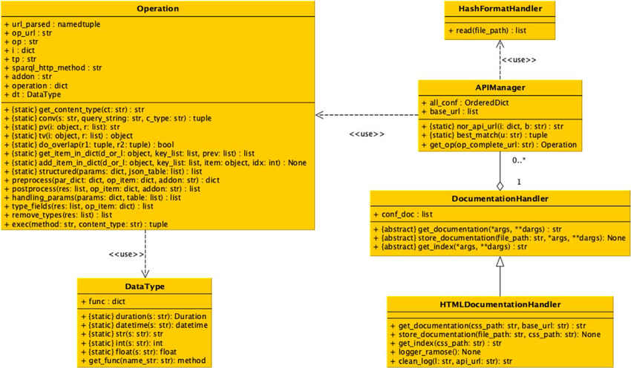
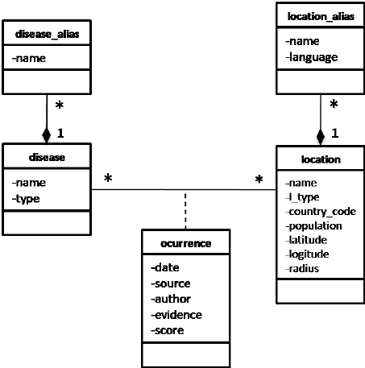

The class diagram shows the structure of the system by defining different classes and their relationships.
In this project, important classes include DataSource, Database, DataProcessor, and Analysis. The DataSource class holds raw traffic data attributes. The Database class represents MySQL tables used for storage. The DataProcessor class handles cleaning and feature engineering in Python. The Analysis class performs SQL queries and generates insights.
These classes are connected to show how data flows through the system, giving a clear view of system structure.
Sequence Diagram
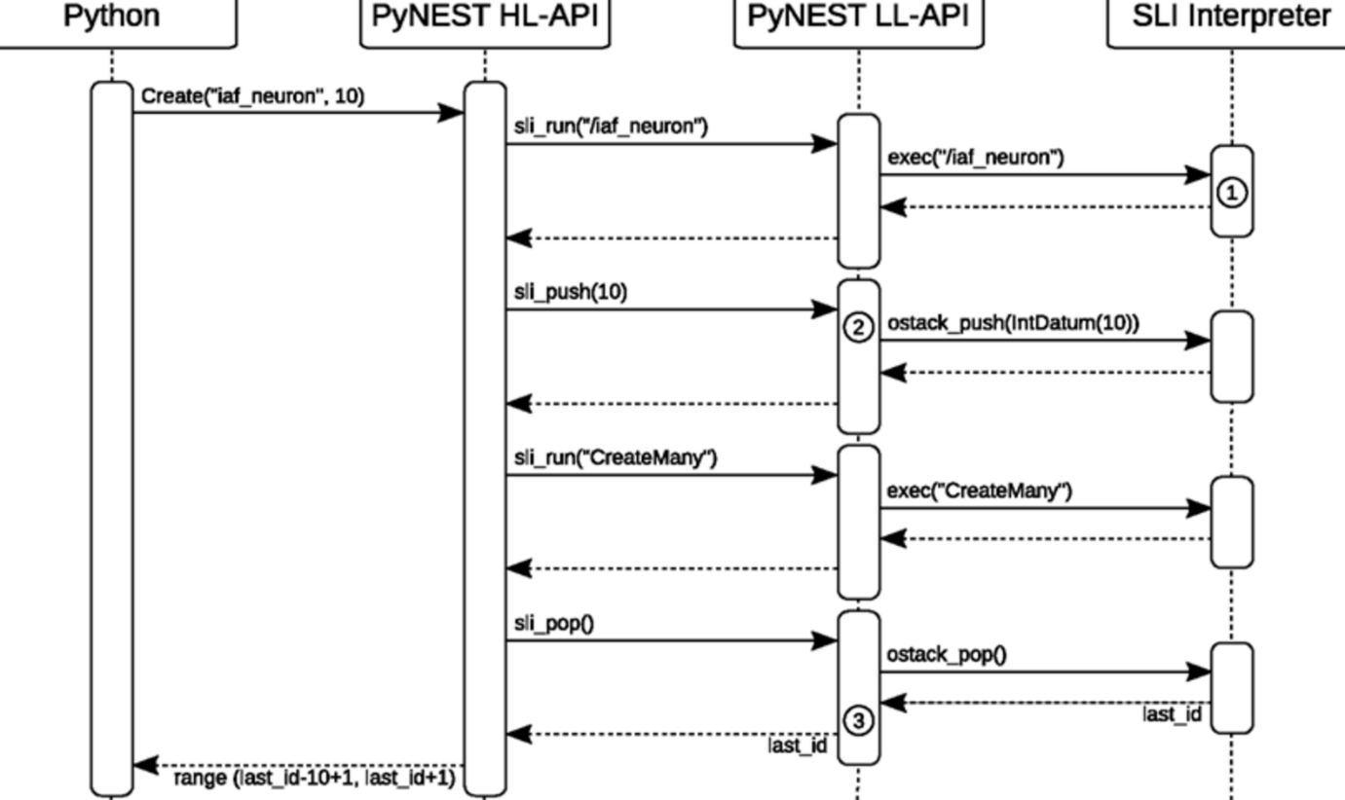
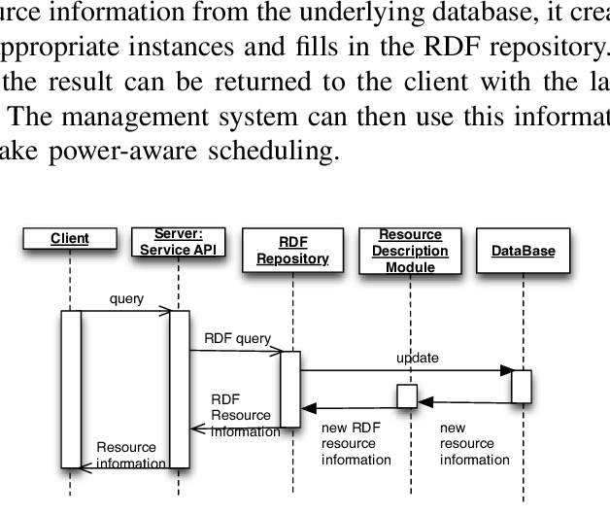
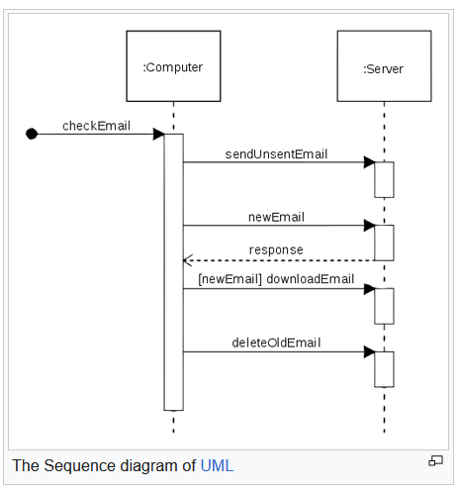
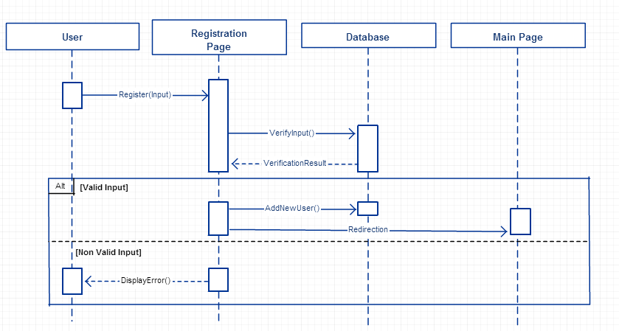
The sequence diagram explains the step-by-step flow of operations in the system.
The process begins with the user uploading the dataset. The data is then cleaned and processed in Python. After preprocessing, the data is stored in the MySQL database. The user runs SQL queries to retrieve specific data. The results are optionally processed further in Python and then presented to the user.
This diagram helps in understanding how different components interact over time and how the workflow progresses from input to final output.

14.Outputs
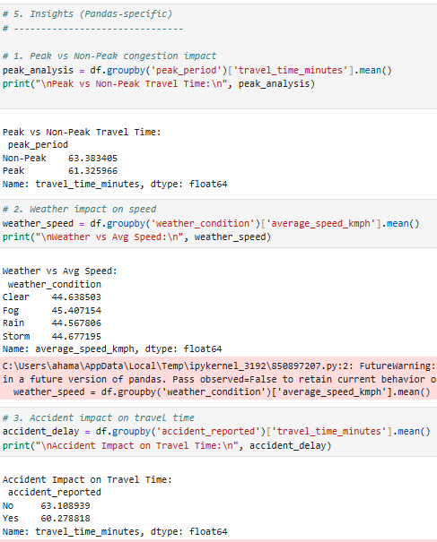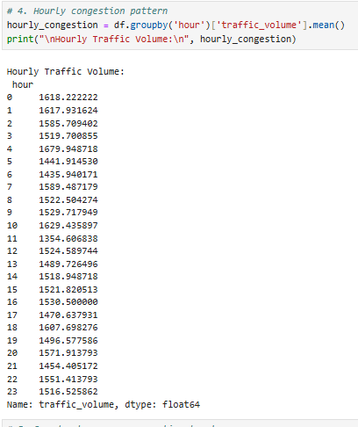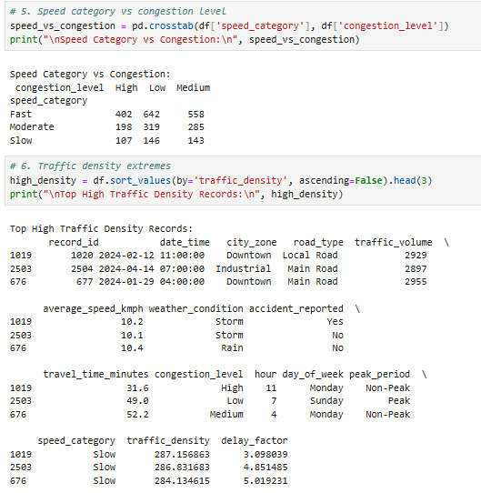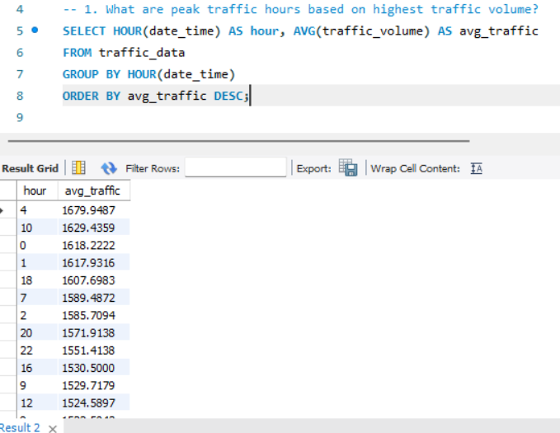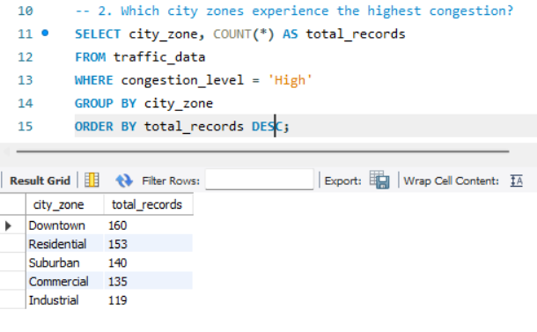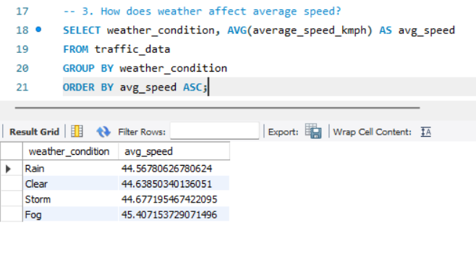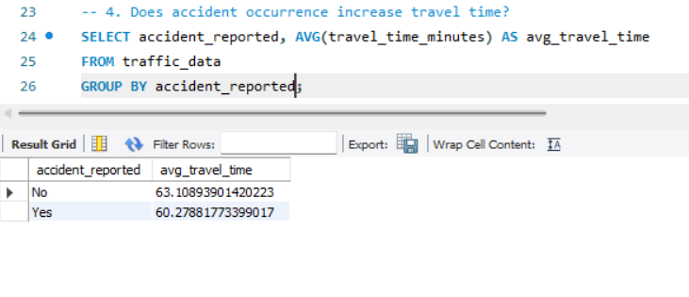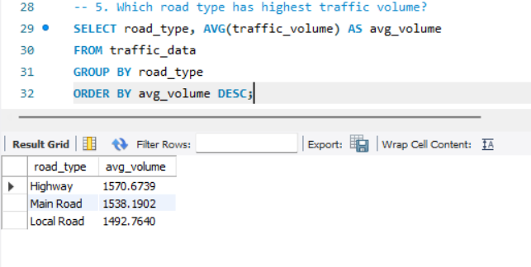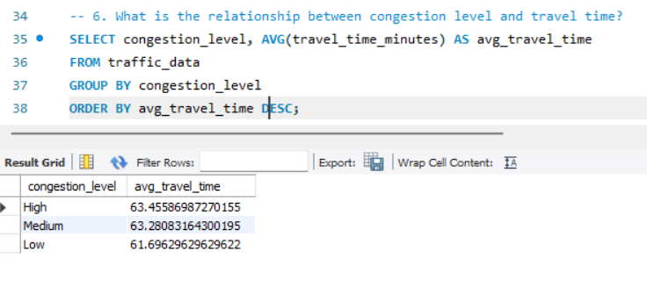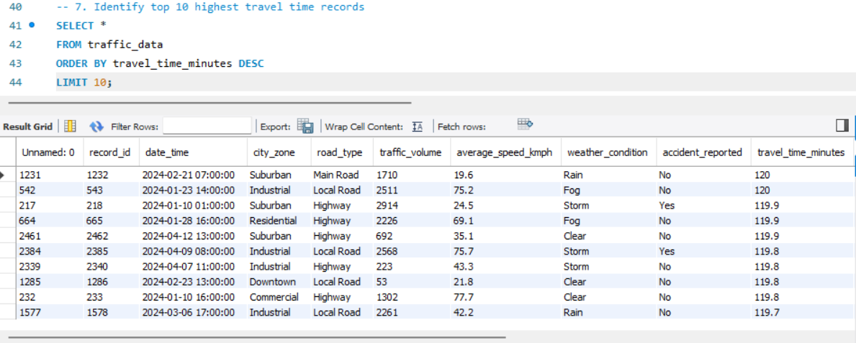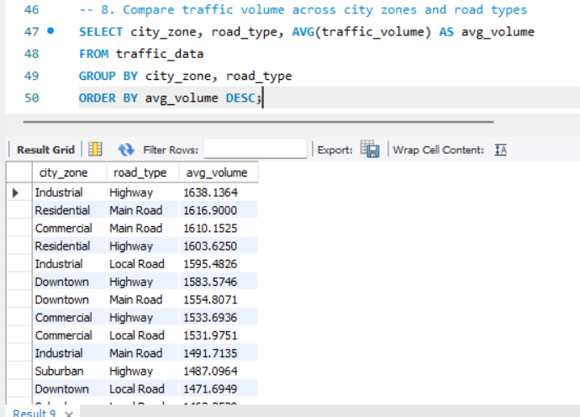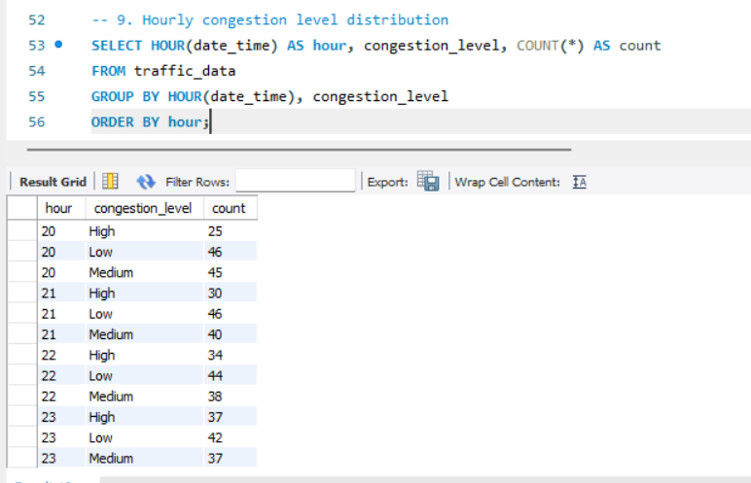
14. OUTPUT AND ANALYSIS
The output and analysis section focuses on the results obtained from SQL queries performed on the traffic dataset. Each query produces a result table that helps in understanding traffic patterns, congestion behavior, and influencing factors. The following analysis explains what each query shows, identifies patterns, and provides meaningful insights based on the outputs .
Query 1: Peak Traffic Hours
This query calculates the average traffic volume for each hour of the day.
The result table shows different hours along with their corresponding average traffic volume. Higher values indicate time periods with more vehicles on the road.
From the output, it can be observed that certain hours, typically morning and evening, have higher traffic volumes compared to other times. These represent peak traffic hours.
The pattern indicates that traffic volume increases during working hours and decreases during late night or early morning.
This insight shows that congestion is time-dependent and is highest during daily commuting periods. It helps in identifying when traffic control measures are most needed.
Query 2: City Zones with Highest Congestion
This query counts the number of records where congestion level is high for each city zone.
The output table lists city zones along with the number of high congestion occurrences.
It can be observed that some zones have significantly higher counts than others, indicating they experience frequent congestion.
The pattern shows that congestion is not evenly distributed across all areas, but is concentrated in specific zones.
This insight highlights critical areas that require better traffic management or infrastructure improvements.
Query 3: Weather Impact on Speed
This query calculates the average speed of vehicles under different weather conditions.
The result shows weather conditions along with their corresponding average speeds.
It is observed that average speed is higher during clear weather and lower during adverse conditions such as rain or storms.
The pattern indicates a direct relationship between weather and vehicle speed, where unfavorable weather reduces speed.
This insight suggests that weather plays an important role in traffic flow and should be considered in traffic planning.
Query 4: Accident Impact on Travel Time
This query compares average travel time based on whether an accident was reported or not.
The output shows two categories, accident reported and not reported, along with their average travel times.
It is clearly observed that travel time is higher when accidents are reported.
The pattern indicates that accidents significantly disrupt traffic flow and increase delays.
This insight emphasizes the importance of quick accident management to reduce congestion.
Query 5: Road Type vs Traffic Volume
This query calculates the average traffic volume for each type of road.
The output lists road types along with their average traffic volumes.
Some road types show higher traffic volumes compared to others, indicating heavier usage.
The pattern suggests that major roads or highways carry more traffic than smaller roads.
This insight helps in understanding which road types require better management and maintenance.
Query 6: Congestion Level vs Travel Time
This query calculates the average travel time for each congestion level.
The result table shows congestion levels such as low, medium, and high along with their corresponding travel times.
It is observed that travel time increases as congestion level increases.
The pattern clearly indicates a direct relationship between congestion and delay.
This insight confirms that higher congestion leads to longer travel durations, affecting overall road efficiency.
Query 7: Highest Travel Time Records
This query retrieves the top records with the highest travel time.
The output displays records where travel time is maximum along with other attributes.
It can be observed that these records often have high traffic volume, low speed, or accident involvement.
The pattern shows that extreme delays occur under a combination of unfavorable conditions.
This insight helps in identifying worst-case scenarios and understanding factors contributing to maximum delays.
Query 8: City Zone and Road Type Comparison
This query analyzes average traffic volume based on both city zone and road type.
The output table shows combinations of city zones and road types with their corresponding traffic volumes.
It is observed that certain combinations have significantly higher values.
The pattern indicates that congestion is influenced by both location and type of road.
This insight provides a deeper understanding of how different factors interact to affect traffic conditions.
Overall Analysis
The SQL query outputs collectively provide a comprehensive view of urban traffic behavior. The results show that traffic congestion is influenced by multiple factors such as time of day, location, weather conditions, road type, and accidents. Peak hours, adverse weather, and accident occurrences are major contributors to increased travel time and congestion levels.
The analysis demonstrates that structured query-based approaches are effective in identifying patterns and extracting meaningful insights from large datasets. These insights can be used to improve traffic management, optimize road usage, and support better planning decisions.
15. CONCLUSION
The analysis of urban traffic congestion in this project successfully demonstrates how structured data analytics can be used to understand complex real-world problems. By working with traffic data containing multiple variables such as time, location, speed, weather conditions, and accidents, the project was able to identify important patterns and relationships that influence congestion. The use of MySQL enabled efficient querying and summarization of large datasets, while Python with Pandas supported data cleaning, transformation, and advanced analysis. As a result, the project achieved its objective of converting raw traffic data into meaningful insights about traffic behavior.
One of the key achievements of this analysis is the identification of peak traffic hours, which clearly show when congestion is most severe. The study also highlights how different factors such as weather conditions and accident occurrences impact vehicle speed and travel time. Variations in congestion across different city zones and road types were identified, providing a better understanding of location-based traffic behavior. Feature engineering further enhanced the dataset by introducing new variables that helped in uncovering deeper insights. Overall, the analysis provided a comprehensive view of how multiple factors interact to influence urban traffic conditions.
Several important learnings were gained during this project. It emphasized the importance of data preprocessing, as clean and well-structured data is essential for accurate analysis. The project also demonstrated how combining SQL and Python creates a powerful analytics workflow, where SQL handles efficient data retrieval and Python enables flexible data processing. Another key learning is that real-world data often contains hidden patterns that can only be discovered through systematic analysis. Understanding these patterns is crucial for making informed decisions.
The benefits of this project are significant in terms of both technical and practical applications. From a technical perspective, it showcases the effective use of data analytics tools to handle large datasets and perform meaningful analysis. From a practical perspective, the insights generated can help in improving traffic management strategies, reducing congestion, and optimizing road usage. Identifying peak hours and high congestion zones can support better planning and resource allocation. Additionally, understanding the impact of external factors such as weather and accidents can help in developing proactive measures to minimize delays.
In conclusion, this project highlights the value of data analytics in solving real-world problems like urban traffic congestion. By applying a structured approach to data collection, preprocessing, querying, and analysis, the project provides useful insights that can contribute to more efficient and effective transportation systems.

